**WOUND CARE PLAN** Date:……………………………………

**Allergies:**

**Wound Type:**

* Surgical
* Non-surgical
* Skin Tear
* Pressure Ulcer
* Chronic
* Other

**Wound Appearance:**

* Epithelisation
* Granulation
* Slough
* Maceration
* Necrosis
* Oedema
* Cellulitis
* Erythema
* Exudate: serous, purulent, bleeding

**Location and diagram of wound/s:**

**Draw wound**:

**Record Dimensions:**

Width: Depth: Length:

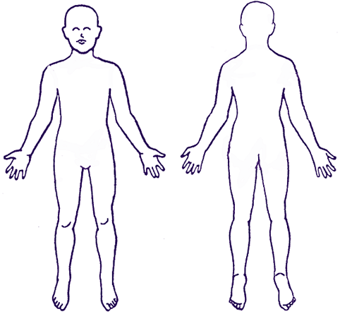

**Dressing Change Rationale:**

* Decrease bacterial load
* Maintain skin integrity
* Breakdown Slough
* Promote cell granulation and tissue healing
* Protect surrounding skin
* Over Granulation
* Other…………………………………………………………………….

**Dressing Product/s Used:**

Primary

Secondary

**Pain Score:**

**Frequency of dressing change:** indicate when due.

|  |  |  |  |  |
| --- | --- | --- | --- | --- |
| Monday | Tuesday | Wednesday | Thursday | Friday |
|  |  |  |  |  |

**Client Acceptance of Treatment:**

……………………………………………………. ……………………………………………………….

Client Signature Client Print Name

**Actioned by:**

…………………………………………………… ……………………………………………………….

Nurse Signature Nurse Print Name

**Review date by surgeon:**

**Cease Care Plan:** state reason, date and sign.

**NURSING NOTES**

|  |  |  |  |
| --- | --- | --- | --- |
| **Date** | **Comments** | **Signature & Print Name** | **EN/RN** |
|  |  |  |  |
|  |  |  |  |
|  |  |  |  |
|  |  |  |  |
|  |  |  |  |
|  |  |  |  |
|  |  |  |  |
|  |  |  |  |
|  |  |  |  |
|  |  |  |  |

**NURSING NOTES**

|  |  |  |  |
| --- | --- | --- | --- |
| **Date** | **Comments** | **Signature & Print Name** | **EN/RN** |
|  |  |  |  |
|  |  |  |  |
|  |  |  |  |
|  |  |  |  |
|  |  |  |  |
|  |  |  |  |
|  |  |  |  |
|  |  |  |  |
|  |  |  |  |
|  |  |  |  |